

Original Instructions

GENERAL POWER TOOL SAFETY WARNINGS

**⚠ WARNING! Read all safety warnings, instructions, illustrations and specifications provided with this power tool.***Failure to follow all instructions listed below may result in electric shock, fire and/or serious injury.*

**Save all warnings and instructions for future reference.**

*The term "power tool" in the warnings refers to your mains-operated (corded) power tool or battery-operated (cordless) power tool.*

**1) Work area safety**

1. **Keep work area clean and well lit.** *Cluttered or dark areas invite accidents.*
2. **Do not operate power tools in explosive atmospheres, such as in the presence of flammable liquids, gases or dust.** *Power tools create sparks which may ignite the dust or fumes.*
3. **Keep children and bystanders away while operating a power tool.** *Distractions can cause you to lose control.*

**2) Electrical safety**

1. **Power tool plugs must match the outlet. Never modify the plug in any way. Do not use any adapter plugs with earthed (grounded) power tools.** *Unmodified plugs and matching outlets will reduce risk of electric shock.*
2. **Avoid body contact with earthed or grounded surfaces, such as pipes, radiators, ranges and refrigerators.** *There is an increased risk of electric shock if your body is**earthed or grounded.*
3. **Do not expose power tools to rain or wet conditions.** *Water entering a power tool will increase the risk of electric shock.*
4. **Do not abuse the cord. Never use the cord for carrying, pulling or unplugging the power tool. Keep cord away from heat, oil, sharp edges or moving parts.***Damaged**or entangled cords increase the risk of electric shock.*
5. **When operating a power tool outdoors, use an extension cord suitable for outdoor use.** *Use of a cord suitable for outdoor use reduces the risk of electric shock.*
6. **If operating a power tool in a damp location is unavoidable, use a residual current device (RCD) protected supply.** *Use of an RCD reduces the risk of electric shock.*

**3) Personal safety**

1. **Stay alert, watch what you are doing and use common sense when operating a power tool. Do not use a power tool while you are tired or under the influence of drugs, alcohol or medication.** *A moment of inattention while operating power tools**may result in serious personal injury.*
2. **Use personal protective equipment. Always wear eye protection.** *Protective equipment such as a dust mask, non-skid safety shoes, hard hat or hearing protection used for appropriate conditions will reduce personal injuries.*
3. **Prevent unintentional starting. Ensure the switch is in the off-position before connecting to power source and/or battery pack, picking up or carrying the tool.** *Carrying power tools with your finger on the switch or energising power tools that have**the switch on invites accidents.*
4. **Remove any adjusting key or wrench before turning the power tool on.** *A wrench or a key left attached to a rotating part of the power tool may result in personal injury.*
5. **Do not overreach. Keep proper footing and balance at all times.** *This enables better control of the power tool in unexpected situations.*
6. **Dress properly. Do not wear loose clothing or jewellery. Keep your hair and clothing away from moving parts.** *Loose clothes, jewellery or long hair can be caught in moving parts.*
7. **If devices are provided for the connection of dust extraction and collection facilities, ensure these are connected and properly used.** *Use of dust collection can reduce dust-related hazards.*
8. **Do not let familiarity gained from frequent use of tools allow you to become complacent and ignore tool safety principles.** *A careless action can cause severe injury within a fraction of a second.*

**4) Power tool use and care**

1. **Do not force the power tool. Use the correct power tool for your application.** *The correct power tool will do the job better and safer at the rate for which it was designed.*
2. **Do not use the power tool if the switch does not turn it on and off.** *Any* *power tool that cannot be controlled with the switch is dangerous and must be repaired.*
3. **Disconnect the plug from the power source and/or remove the battery pack, if detachable, from the power tool before making any adjustments, changing accessories, or storing power tools.** *Such preventive safety measures reduce the risk of starting the power tool accidentally.*
4. **Store idle power tools out of the reach of children and do not allow persons unfamiliar with the power tool or these instructions to operate the power tool.***Power tools are dangerous in the hands of untrained users.*
5. **Maintain power tools and accessories. Check for misalignment or binding of moving parts, breakage of parts and any other condition that may affect the power tool’s operation. If damaged, have the power tool repaired before use.** *Many accidents are caused by poorly maintained power tools.*
6. **Keep cutting tools sharp and clean.** *Properly maintained cutting tools with sharp cutting edges are less likely to bind and are easier to control.*
7. **Use the power tool, accessories and tool bits etc. in accordance with these instructions, taking into account the working conditions and the work to be performed.** *Use of the power tool for operations different from those intended could**result in a hazardous situation.*
8. **Keep handles and grasping surfaces dry, clean and free from oil and grease.** *Slippery handles and grasping surfaces do not allow for safe handling and control of the tool in unexpected situations.*

**5) Service**

1. **Have your power tool serviced by a qualified repair person using only identical replacement parts*.*** *This will ensure that the safety of the power tool is maintained.*

THE SYMBOLS IN INSTRUCTION MANUAL

|  |  |
| --- | --- |
|  | Double insulated for additional protection |
|  | Read the instruction manual before using. |
|  | CE conformity. |
|  | Safety alert.  Please only use the accessories supported by the manufacturer. |
|  | Wear safety glasses, hearing protection and dust mask. |
|  | WARNING! Always operate with two hands |
|  | Do not use the guard for cut-off operations. When working with cut-off wheels, always use the parting safety guard for safety reasons |
|  | Waste electrical products should not be disposed of with household waste. Please recycle where facilities exist. Check with your Local Authority or retailer for recycling advice. |

ADDITIONAL SAFETY WARNING

Safety instructions for all operations

**Safety warnings common for grinding, sanding, wire brushing, polishing or cutting-off operations:**

1. **This power tool is intended to function as a grinder, sander, wire brush, polisher or cut-off tool. Read all safety warnings, instructions, illustrations and specifications provided with this power tool.** *Failure to follow all instructions listed below may result in electric shock, fire and/or serious injury.*
2. **Do not convert this power tool to operate in a way which is not specifically designed and specified by the tool manufacturer.** *Such a conversion may result in a loss of control and cause serious personal injury.*
3. **Do not use accessories which are not specifically designed and recommended by the tool manufacturer**. *Just because the accessory can be attached to your power tool, it does not assure safe operation*.
4. **The rated speed of the accessory must be at least equal to the maximum speed marked on the power tool**. *Accessories running faster than their rated speed can break and fly apart.*
5. **The outside diameter and the thickness of your accessory must be within the capacity rating of your power tool**. *Incorrectly sized accessories cannot be adequately guarded or controlled.*
6. **The dimensions of the accessory mounting must fit the dimensions of the mounting hardware of the power tool.** *Accessories that do not match the mounting hardware of the power tool will run out of balance, vibrate excessively and may cause loss of control.*
7. **Do not use a damaged accessory. Before each use inspect the accessory such as abrasive wheels for chips and cracks, backing pad for cracks, tear or excess wear, wire brush for loose or cracked wires. If power tool or accessory is dropped, inspect for damage or install an undamaged accessory. After inspecting and installing an accessory, position yourself and bystanders away from the plane of the rotating accessory and run the power tool at maximum no-load speed for one minute.** *Damaged accessories will normally break apart during this test time.*
8. **Wear personal protective equipment. Depending on application, use face shield, safety goggles or safety glasses. As appropriate, wear dust mask, hearing protectors, gloves and workshop apron capable of stopping small abrasive or workpiece fragments**. *The eye protection must be capable of stopping flying debris generated by various operations. The dust mask or respirator must be capable of filtrating particles generated by your operation. Prolonged exposure to high intensity noise may cause hearing loss*.
9. **Keep bystanders a safe distance away from work area. Anyone entering the work area must wear personal protective equipment**. *Fragments of workpiece or of a broken accessory may fly away and cause injury beyond immediate area of operation.*
10. **Hold the power tool by insulated gripping surfaces only, when performing an operation where the cutting accessory may contact hidden wiring or its own cord.** *Cutting accessory contacting a “live” wire may make exposed metal parts of the power tool “live” and could give the operator an electric shock*.
11. **Position the cord clear of the spinning accessory**. *If you lose control, the cord may be cut or snagged and your hand or arm may be pulled into the spinning accessory.*
12. **Never lay the power tool down until the accessory has come to a complete stop***. The spinning accessory may grab the surface and pull the power tool out of your control*.
13. **Do not run the power tool while carrying it at your side**. *Accidental contact with the spinning accessory could snag your clothing, pulling the accessory into your body.*
14. **Regularly clean the power tool’s air vents**. *The motor’s fan will draw the dust inside the housing and excessive accumulation of powdered metal may cause electrical hazards.*
15. **Do not operate the power tool near flammable materials**. *Sparks could ignite these materials.*
16. **Do not use accessories that require liquid coolants**. *Using water or other liquid coolants may result in electrocution or shock*.

Further safety instructions for all operations

**Kickback and related warnings:**

Kickback is a sudden reaction to a pinched or snagged rotating wheel, backing pad, brush or any other accessory. Pinching or snagging causes rapid stalling of the rotating accessory which in turn causes the uncontrolled power tool to be forced in the direction opposite of the accessory’s rotation at the point of the binding.

For example, if an abrasive wheel is snagged or pinched by the workpiece, the edge of the wheel that is entering into the pinch point can dig into the surface of the material causing the wheel to climb out or kick out. The wheel may either jump toward or away from the operator, depending on direction of the wheel’s movement at the point of pinching. Abrasive wheels may also break under these conditions.

Kickback is the result of power tool misuse and/or incorrect operating procedures or conditions and can be avoided by taking proper precautions as given below.

1. **Maintain a firm grip on the power tool and position your body and arm to allow you to resist kickback forces. Always use auxiliary handle, if provided, for maximum control over kickback or torque reaction during start-up**. *The operator can control torque reactions or kickback forces, if proper precautions are taken*.
2. **Never place your hand near the rotating accessory**. *Accessory may kickback over your hand.*
3. **Do not position your body in the area where power tool will move if kickback occurs.** *Kickback will propel the tool in direction opposite to the wheel’s movement at the point of snagging*.
4. **Use special care when working corners, sharp edges etc. Avoid bouncing and snagging the accessory**. *Corners, sharp edges or bouncing have a tendency to snag the rotating accessory and cause loss of control or kickback*.
5. **Do not attach a saw chain woodcarving blade, segmented diamond wheel with a peripheral gap greater than 10 mm or toothed saw blade**. *Such blades create frequent kickback and loss of control.*

Additional safety instructions for grinding and cutting-off operations

**Safety warnings specific for grinding and abrasive cutting-off operations:**

1. **Use only wheel types that are recommended for your power tool and the specific guard designed for the selected wheel**. *Wheels for which the power tool was not designed cannot be adequately guarded and are unsafe*.
2. **The grinding surface of center depressed wheels must be mounted below the plane of the guard lip**. *An improperly mounted wheel that projects through the plane of the guard lip cannot be adequately protected*.
3. **The guard must be securely attached to the power tool and positioned for maximum safety, so the least amount of wheel is exposed towards the operator**. *The guard helps to protect the operator from broken wheel fragments, accidental contact with wheel and sparks that could ignite clothing*.
4. **Wheels must be used only for recommended applications. For example: do not grind with the side of cut-off wheel**. *Abrasive cut-off wheels are intended for peripheral grinding, side forces applied to these wheels may cause them to shatter.*
5. **Always use undamaged wheel flanges that are of correct size and shape for your selected wheel**. *Proper wheel flanges support the wheel thus reducing the possibility of wheel breakage. Flanges for cut-off wheels may be different from grinding wheel flanges*.
6. **Do not use worn down wheels from larger power tools**. *Wheel intended for larger power tool is not suitable for the higher speed of a smaller tool and may burst.*
7. **When using dual purpose wheels always use the correct guard for the application being performed.** *Failure to use the correct guard may not provide the desired level of guarding, which could lead to serious injury.*

Additional safety instructions for cutting-off operations

**Additional safety warnings specific for cutting-off operations:**

1. **Do not “jam” the cut-off wheel or apply excessive pressure. Do not attempt to make an excessive depth of cut**. *Overstressing the wheel increases the loading and susceptibility to twisting or binding of the wheel in the cut and the possibility of kickback or wheel breakage*.
2. **Do not position your body in line with and behind the rotating wheel**. *When the wheel, at the point of operation, is moving away from your body, the possible kickback may propel the spinning wheel and the power tool directly at you.*
3. **When wheel is binding or when interrupting a cut for any reason, switch off the power tool and hold the power tool motionless until the wheel comes to a complete stop. Never attempt to remove the cut-off wheel from the cut while the wheel is in motion otherwise kickback may occur**. *Investigate and take corrective action to eliminate the cause of wheel binding*.
4. **Do not restart the cutting operation in the workpiece. Let the wheel reach full speed and carefully re-enter the cut**. *The wheel may bind, walk up or kickback if the power tool is restarted in the workpiece*.
5. **Support panels or any oversized workpiece to minimize the risk of wheel pinching and kickback**. *Large workpieces tend to sag under their own weight. Supports must be placed under the workpiece near the line of cut and near the edge of the workpiece on both sides of the wheel*.
6. **Use extra caution when making a “pocket cut” into existing walls or other blind areas**. *The protruding wheel may cut gas or water pipes, electrical wiring or objects that can cause kickback*.
7. **Do not attempt to do curved cutting**. *Overstressing the wheel increases the loading and susceptibility to twisting or binding of the wheel in the cut and the possibility of kickback or wheel breakage, which can lead to serious injury.*

**Additional safety instructions for sanding operations**

**Safety warnings specific for sanding operations:**

1. **Use proper sized sanding disc paper. Follow manufacturers recommendations, when selecting sanding paper.** *Larger sanding paper extending too far beyond the sanding pad presents a laceration hazard and may cause snagging, tearing of the disc or kickback*.

**Additional safety instructions for polishing operations**

**Safety warnings specific for polishing operations:**

1. **Do not allow any loose portion of the polishing bonnet or its attachment strings to spin freely. Tuck away or trim any loose attachment strings.** Loose and spinning attachment strings can entangle your fingers or snag on the workpiece.

**Additional safety instructions for wire brushing operations**

**Safety warnings specific for wire brushing operations:**

1. **Be aware that wire bristles are thrown by the brush even during ordinary operation. Do not overstress the wires by applying excessive load to the brush.** *The wire bristles can easily penetrate light clothing and/or skin*.
2. **If the use of a guard is recommended for wire brushing, do not allow any interference of the wire wheel or brush with the guard**. *Wire wheel or brush may expand in diameter due to work load and centrifugal forces*.

Residual risks

Even when the power tool is used as prescribed it is not possible to eliminate all residual risk factors. The following hazards may arise in connection with the power tool’s construction and design:

1. Health defects resulting from vibration emission if the power tool is being used over longer period of time or not adequately managed and properly maintained.
2. Injuries and damage to property to due to broken accessories that are suddenly dashed.

**⚠ WARNING**!

**This power tool produces an electromagnetic field during operation. This field may under some circumstances interfere with active or passive medical implants. To reduce the risk of serious or fatal injury, we recommend persons with medical implants to consult their physician and the medical implant manufacturer before operating this power tool.**

INTENDED USE

The angle grinder suitable for grinding, sanding, abrasive cutting-off operations and wire brushing metal, concrete, stone and similar materials without the use of water.

Specifications

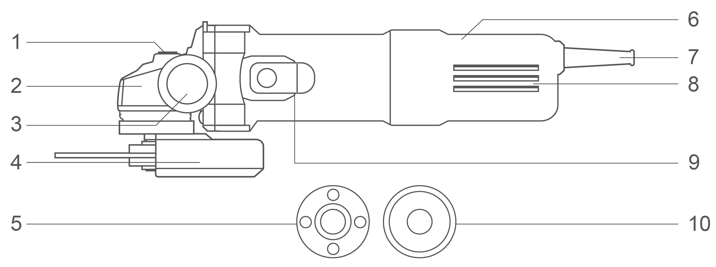

**Components**

|  |  |
| --- | --- |
| 1. Spindle locking button 2. Aluminum gear box 3. Auxiliary handle 4. Disc guard 5. Thread lock flange | 1. Housing 2. Power cable sleeve 3. Cooling vents 4. On/off switch button 5. Mounting washer flange |

Accessories

1. Auxiliary handle 1pcs
2. Spanner 1pcs

Technical specifications

|  |  |  |
| --- | --- | --- |
| Model No. | AG75028  AG75028xy | UAG75028  UAG75028xy |
| **Rated input power** | 750W | 750W |
| **Rated voltage** | 220-240V~50/60Hz | 110-120V~50/60Hz |
| **Rated no-load speed** | 12000/min | 12000/min |
| **Grinding spindle thread** | M14 | 5/8˝-11UNC |
| **Disc diameter** | 115mm | 4-1/2˝ |
| **Protection class** | 回/II | 回/II |

|  |  |  |
| --- | --- | --- |
| Model No. | AG75028-9  （INMETRO Plug） | UAG75028-91  （INMETRO Plug） |
| **Rated input power** | 750W | 750W |
| **Rated voltage** | 220-240V~60Hz | 127V~60Hz |
| **Rated no-load speed** | 12000/min | 12000/min |
| **Grinding spindle thread** | M14 | M14 |
| **Disc diameter** | 115mm | 4-1/2˝ |
| **Protection class** | 回/II | 回/II |

|  |  |  |
| --- | --- | --- |
| Model No. | AG75028-8E | AG750283 |
| **Rated input power** | 750W | 750W |
| **Rated voltage** | 220-240V~50/60Hz | 220-240V~50/60Hz |
| **Rated no-load speed** | 12000/min | 12000/min |
| **Grinding spindle thread** | M14 | M10 |
| **Disc diameter** | 115mm | 100mm |
| **Protection class** | 回/II | 回/II |

**Model No. NOTE:** x (blank, 1,2,3,4,5,6,7,8,9,E,S,A,M); y (blank, -1,-2,-3,-4,-5,-6,-7,-8,-9,E,S,A,M)

* Due to our continuing program of research and development, the specifications herein are subject to change without notice.

**Noise/Vibration information**

The noise emission, measured in accordance with EN62841-2-3:

|  |  |  |
| --- | --- | --- |
| Sound pressure level | LpA | 94 dB (A) |
| Sound power level | LwA | 102 dB (A) |
| Uncertainty | K | 3 dB (A) |

**Wear hearing protection!**

The vibration total value and its uncertainty determined according to EN62841-2-3:

**Surface grinding:**

|  |  |  |
| --- | --- | --- |
| Vibration emission value | ah,AG | 9,3 m/s2 |
| Uncertainty | K | 1,5 m/s2 |

**NOTE:** For other applications, e.g., abrasive cutting-off operations or wire brushing other vibration values could occur.

That the declared vibration total value has been measured in accordance with a standard test method and may be used for comparing one tool with another.

That the declared vibration total value may also be used in a preliminary assessment of exposure.

**⚠ WARNING!**

* **That the vibration emission during actual use of the power tool can differ from the declared total value depending on the ways in which the tool is used;**
* **Identify safety measures to protect the operator that are based on an estimation of exposure in the actual conditions of use (taking account of all parts of the operating cycle such as the times when the tool is switched off and when it is running idle in addition to the trigger time).**

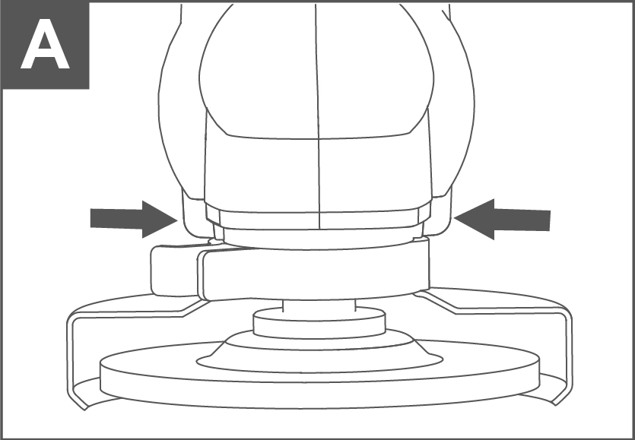Operation picture

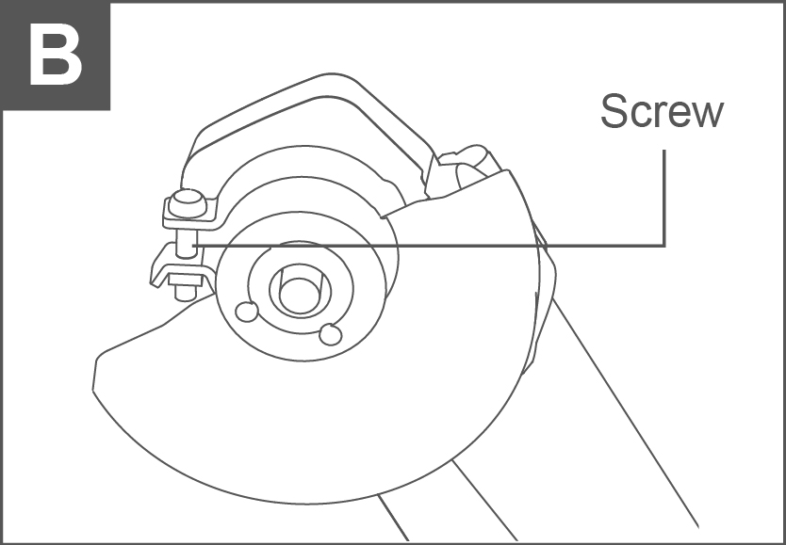

**A**

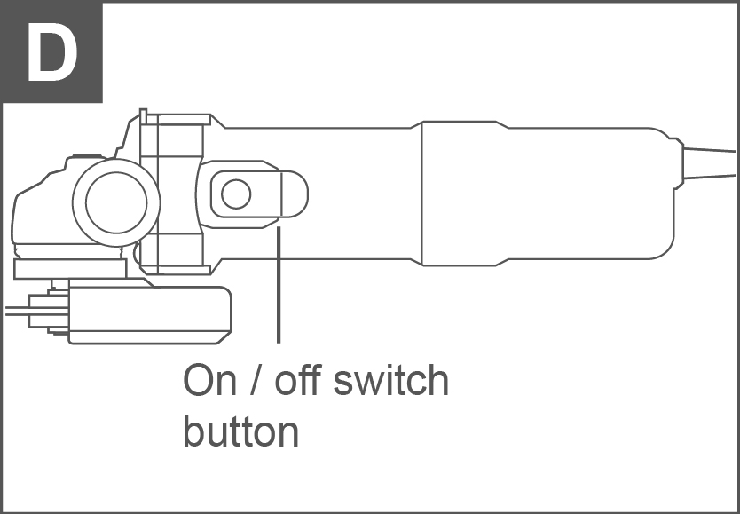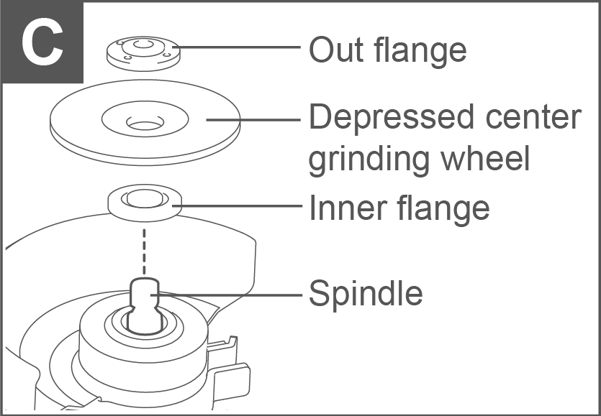

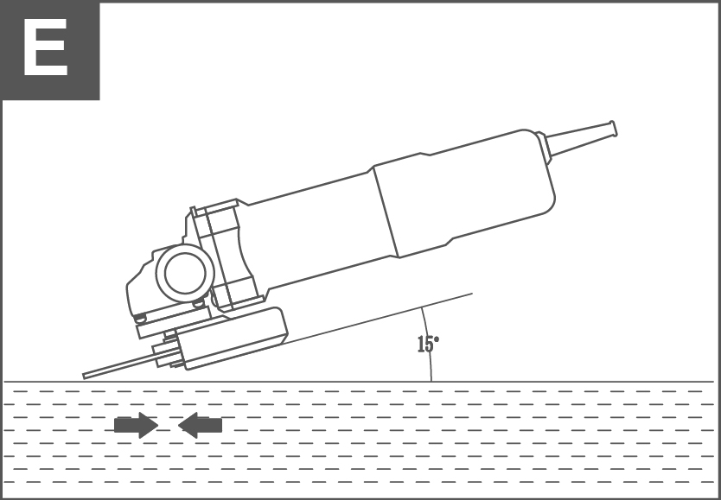

OPERATION

**⚠ WARNING!**

**Before using your angle grinder, be sure to read the instruction manual carefully.**

Installing the auxiliary handle (see Figure A)

An auxiliary handle is supplied and can be fixed into both of the two positions on the gearcase. If you are right-handed fit the handle as shown in Figure A. If you are left-handed fit the handle the other way round. When using a cutting disc, you can screw the handle into the position on top of the gearcase.

**NOTE:** This handle should be used at all times to maintain complete control of the tool.

Adjusting wheel guard (see Figure B)

Adjust the guard to protect your hands and direct grinding debris. Loosen the screw. Position the guard at the required angle. Then tighten the screw.

**⚠ CAUTION!**

**Be sure that the guard is secure before starting the angle grinder.**

**⚠ WARNING!**

Never use the angle grinder without the disc guard in place.

Fitting the discs (see Figure C)

Place the grinding/cutting disc on top of the inner flange and over the spindle. Ensure that it is firmly located on the raised section of the inner flange (see Figure C). Locate the outer flange over the disc, making sure that the raised side is facing the disc and is fully located in the centre hole of the disc.

**NOTE:**

* When clamping thin section metal diamond discs, the outer flange must be reversed so that the flat/dished side screws against the disc hub.
* Press and hold down the spindle lock button and tighten the outer flange using the two-pin locking wrench. It may be necessary to turn the spindle to fully locate the spindle lock button.
* When the outer flange washer is tight, release the spindle lock button and remove the wrench.

Switch (see Figure D)

The On/Off trigger switch is sprung in the OFF position. The angle grinder is started by pushing forward the on/off switch (see Figure D). To stop the angle grinder, release the on/off switch and it will return to the OFF position.

**⚠ WARNING!**

The disc will continue rotate for a few seconds after the angle grinder has been switched off.

Always wait until the disc has stopped completely before putting the angle grinder down. Do not attempt to operate the spindle lock button while the disc is still rotating.

To use grinder (see Figure E)

**⚠ ATTENTION!**

Do not switch the grinder on whilst the disc is in contact with the workpiece. Allow the disc to reach full speed before starting to grind. Hold your angle grinder with one hand on the main handle and other hand firmly around d the auxiliary handle.

Always position the guard so that as much of the expose d disc as possible is pointing away from you. Be prepared for a stream of sparks when the disc touches the metal.

For best tool control, material removal and minimum overloading, maintain an angle between the disc and work surface of approximately 15°-30° when grinding and 10°-15° When sanding. Exert light pressure on abrasive discs for efficient operation. Pushing too hard will cause a drop in speed and may result in motor overload and damage.

Use caution when working into corners as contact with the intersecting surface may cause the grinder to jump or twist, when grinding is complete allow the workpiece to cool. Do not touch the hot surface.

Overload

Overloading will cause damage to the motor of your angle grinder. This can happen if your angle grinder is subjected to heavy use for prolonged periods of time.

Do not in any circumstances, attempt to exert too much pressure on your angle grinder to speed up your work.

The abrasive discs operate more efficiently when light pressure is exerted, thus avoiding a drop in the speed of your angle grinder. If your angle grinder becomes too hot, run your angle grinder under no load for 2-3 minutes until it has cooled to normal operation temperature.

Working hints for your angle grinder

1. Your angle grinder is useful for both cutting through metals, i.e. for r removing screw heads, and also for cleaning / preparing surfaces, i.e. before and after welding operations.
2. Different types of wheel/cutters will allow the grinder to meet various needs. Typically, grinding wheels/cutting discs are available for mild steel, stainless steel, stone and brick. Diamond impregnated discs are available for very hard materials.
3. If the grinder is used on soft metals such as aluminium the wheel will soon clog and will have to be changed.
4. At all times, let the grinder do the work, do not force it or apply excessive pressure to the wheel/disc.
5. If cutting a slot ensure that the cutter is kept aligned with the slot, twisting the cutter may cause the disc to shatter. If cutting through thin sheet, only allow the cutter to just project through the material, excessive penetration can increase the chance of causing damage.
6. If cutting stone or brick, it is advisable to use a dust extractor.

Maintenance

**⚠ WARNING!**

Ensure the grinder is disconnected from the mains power supply before attempting any maintenance.

1. Keep the grinder ventilation slots clean and free from obstructions. If available, blow compressed air into the vents to clear any internal dust (safety goggles must be worn when undertaking this process).
2. Keep the outer case of the grinder clean and free from grease, do not wash with water or use solvents or abrasive. Use only mild soap and a damp cloth to clean the tool. Never let any liquid get inside the tool. Never immerse any part of the too into a liquid.
3. Your angle grinder requires no additional lubrication. There are no user serviceable parts in your power tool.
4. Always store your power tool in a dry place.
5. If you see some sparks flashing in the ventilation slots, this normal and will not damage your power tool.

Troubleshooting

Although your new angle grinder is really very simple to operate, if you do experience problems, please check the following:

1. If your grinder will not operate, check the power at the mains plug.
2. If your grinder wheel wobbles or vibrates, check that outer flange is tight, check that the wheel is correctly located on the flange plate.
3. If there is any evidence that the wheel is damaged, do not use as the damaged wheel may disintegrate, remove it and replace with a new wheel. Dispose of old wheels sensibly.
4. If working on aluminium or a similar soft alloy, the wheel will soon become clogged and will not grind effectively.

Environmental protection

Waste electrical products must not be disposed of with household waste. Please recycle where facilities exist. Check with your local authorities or retailer for recycling advice.

MAINTENANCE&MALFUNCTIONS

Possible malfunctions and methods of their eliminations

|  |  |  |
| --- | --- | --- |
| Malfunction | Probable causes | Actions |
| When the machine is turned on, the electric motor does not work. | ● Switch failure  ●The power cord or wiring is broken, power cord plug malfunction;  ● No brush contact with the collector;  ● Wear/damage of brushes | Disconnect the machine from the mains and contact a qualified specialist. |
| Formation of a circular fire on the collector | ● Brush wear/damage of the brush holder;  ● Malfunction in the armature coil | Disconnect the machine from the mains and contact a qualified specialist. Please don’t repair the machine by your own. |
| When working, smoke or the smell of burning insulation appears from the ventilation openings. | ● Malfunction in the electric motor coil;  ● Malfunction of the electrical part of the tool. |
| Increased noise in the gearbox | ● Wear/breakage of gears or bearings |
| When the machine is turned on, the spindle does not rotate | ● Gearbox failure. |

Critical state criteria

|  |  |  |
| --- | --- | --- |
| Critical state criteria | Probable causes | Actions |
| Cracks on the surfaces of bearing and housing parts | Fatigue deformation of metal | Disconnect the machine from the mains and contact a qualified specialist. Please don’t repair the machine by your own. |
| The power cord or plug is damaged | Overload or breakage |
| Excessive wear or damage to the motor or reductor mechanism, or a combination of signs | Fatigue deformation of metal |

Critical state criteria

|  |  |
| --- | --- |
| List of critical failures | Actions |
| Electric motor sparking | It is necessary to contact a qualified specialist |
| The appearance of extraneous noise | It is necessary to contact a qualified specialist |
| If the above malfunctions are detected, it is necessary to disconnect the machine from the mains and contact a qualified specialist | |

